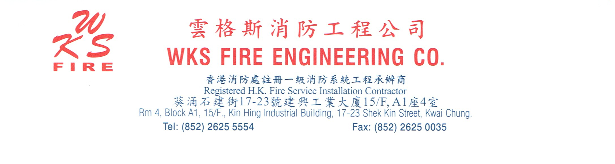

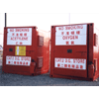 | 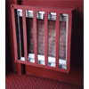 | 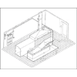
Company Profile & Services Guideline

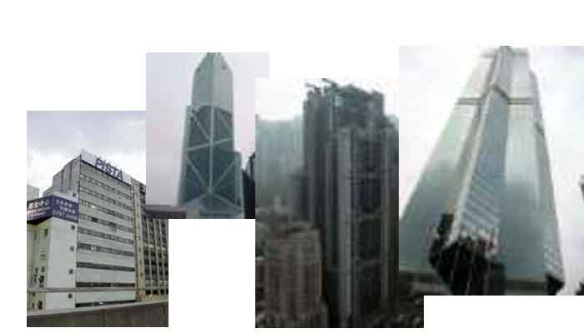
Forword  As the WKS Fire Engineering firm's person in charge, hoped this homepage can provide the practical information for everybody, and even more understood to us. This company officially starts doing business in July, 2001, the goal is impels the engineering development and the electronic commerce. Just like the very many projects same business is same, opens own engineering firm always is one of our desires, formerly rented the cost heavily, was not easy to implement, now the Internet day by day is mature, we happen to utilized itself resources and the technology open the website.  Some people ask us: Hong Kong had the large-scale engineering firm, occupies the field superiority, what do we have compared to their superior place? We believe, the users like patronizing the large-scale engineering firm, also likes the service which likes we equally middle and small scale engineering firm to provide. Because although the middle and small scale engineering firm's class of service are less, but their service often the next to the skin with and conforms to the need. First the price is usually cheaper, two comes the middle and small scale engineering firm to have affinity and the warm atmosphere which one kind is in sole possession of. You entered the middle and small scale engineering firm, very little no good result. We hoped this website also can cause the user to have the similar feeling.  In addition, our also hoped through manages this website to come the reality to participate in Hong Kong the electronic commerce, because although present everybody talk the electronic commerce, the Hong Kong electronic commerce development actually still in the start stage, by far fell behind other advanced countries. Hong Kong must develop the science and technology, really must add a vigor. We expected this website can find high-quality service at the same time for you which needs, also can grow together with Hong Kong's electronic commerce.  Besides the project service, the fire product sale is the WKS Fire Engineering firm's another important service.  If, the WKS Fire Engineering firm sells the fire product, is the quality guarantee, believed nobody can oppose. Since continuously, WKS Fire Engineering firm regardless of is sells the fire extinguisher, the detector, sprinkler and the emergency lighting, or the fire door, the flowered prime fire prevention thing, our purchase policy all is requests the high innate nature the work, has specialized manner which rather lacks do not overflow.  Also is precisely because has achieved the quality guarantee, establishes the high quality brand, the WKS Fire Engineering firm becomes many high innate nature manufacturer chooses when the proxy for theirs painstaking care product the first choice.  The WKS Fire Engineering firm therefore all enjoys in this locality and the overseas has the great reputation, except that because we request in various aspects service rigorously outside, since long ago we warm-heartedly impel the Hong Kong Occupational safety and health and the protection environment culture, also receives public figure's affirmation and the appreciation. Our sincere believing, conducts each kind of Occupational safety and health activity, encourages the staff to pay attention to the security, encourages the environment protection, is our body for a engineering individual contribution responsibility.  But in order to strengthen with the general users' communication, simultaneously provides newest related information and so on project service, fire product sale for the user, we have set up this website. We hoped through the on-line relation, establishes closer relations with you, also hoped you can give the opinion.  Without doubt, Hong Kong has become me and a user's inalienable part, regarding we which grows together say, have say the endless sentiment. This family forever belongs to us, we loves it, it also warmly hugs our all. Follows the life, we in this birth, study with the love, so that marriage and so on. In order to this family prospers stabilizes, in order to enjoy a good and prosperous life and the life is joyful, we do not have the word not to worry pays, best hands over. After the return, this place has had many matters. SARS, the birds and beasts flu, the financial storm change with other nature and man-made disasters the Pearl of the Orient is a mass of cuts and bruises, makes our that to have a thing in the world, makes we to change... ... ... . However, we are willing to go through fire or water for you, are you which is sincere offer our first. The management project service and the fire product sale enterprise, we do not dare to say has the very great sense of mission., but in some degree, we indeed hoped can the affiliation high quality project service and the fire product sale, makes 1. Contributions to the society to the engineering.  Ricky Cheng  17-1-2005 |       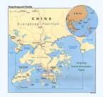    

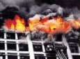 | About our Company  WKS Fire Engineering Co. had been registered as a Fire Service Department approved Class 1, 2, 3 fire services installation contractor. Our Company structure are well and Prefect, moreover, we provide different types of fire services Engineering. For example, installation, design and maintenance of fire services equipment so we are able to offer professional services & advice. We commit to provide quality services to our esteemed clients with competitive price. In addition, we have to provide full range of services by a team of professional and competent staff. Our aims are to provide quality services and to complete the projects to the clients' satisfaction. We provide services to most of buildings in Hong Kong, such as factories, office, hospital, bank, Children Care Centre, Cinema, Restaurant, port, shaopping centres, schools and so on. We have independent workshop, supported by everybody to develop continuous our business. We are the authorized agent for various kinds of advanced fire service equipments such as fire extinguishers, fire hydrant, ventilation fire damper, hosr reel, heat/smoke detection system, FM200/Co2 system, exit sign, emergency lights & water dampers, etc.
Every project of Our company have austere requirement to make perfect. Highly professional management and best engineering quality obtain good comments from building's owner, becoming well-reputed company. Our comapny focus on Financial control, occupational safety, working period, quality assurance and so on. The detail is following: (1)Financial Control
Our company downhold engineering costs to assure that all of cost do not beyond client's budget, to indirectly protect consumer right.
(2)Quality Assurance
Every project of Our company use electrical & mechanical department recognized supervisor" to monitor the working procedure of site, and carry out inspection by licensed person, to assure qualify of work.
(3) Occupational safety
To achieve highest safety standard, our company conform to requirement of building department and labour department, to provide necessary safety accessories for worker, and make full & decorous site safety policy. All of staffs must obey and operates.
(4)Working Period
Our comapny provide work progress report to owner and architect for reference, and follow work progress instruction to carry out the project, to complete the porject on time.
Our Vision
Team work, cost effectiveness, relentless quest for success, entrepreneurship, professionalism, continuous improvement to achieve:
Fulfil both Government and corporate objectives
Maintain financial strength
To provide comprehensive fire engineering services with zenith quality and safety
To deliver our services with innovation and professionalism
To care for the environment of our stakeholders
To deliver our services with innovation and professionalism
Develop sound business partnerships
Build teamwork and commitment in staff
Serve customers and meet performance pledges
Encourage initiative and reward success
To be the industry leader

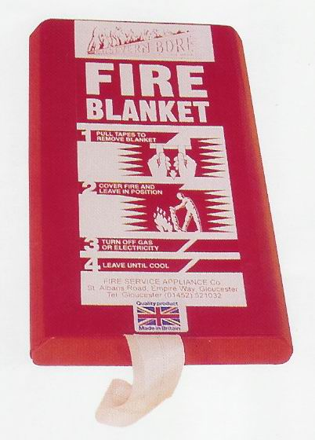 | 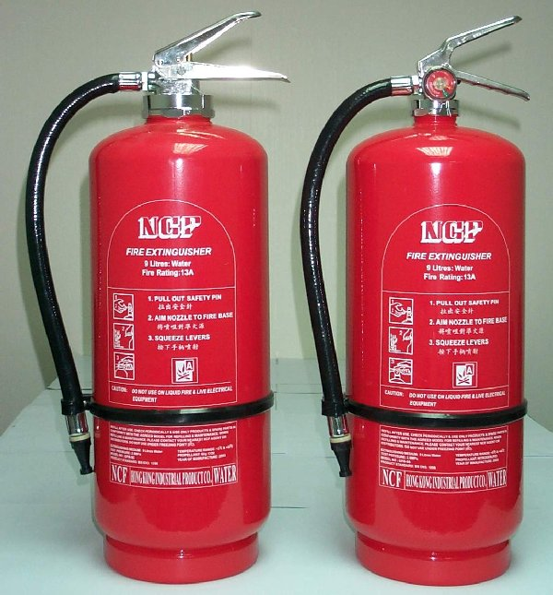 | 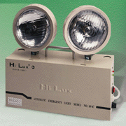
Our Objectives
To be a world leader in providing quality engineering services on the basis of prudent principles.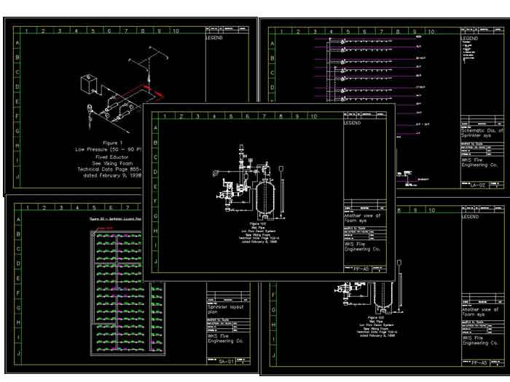
Company History
WKS Fire Engineering Co.(雲格斯消防工程公司) was established by Ricky W.Y. Cheng in July 2003 . Our company registered as a company in Hong Kong Special Administration Zone, comprising several shareholders. Nowadays, we employ beyond 10 people in Hong Kong.

Quality Management System
Our company have perfect quality management system, refering to relevant standard. All fire equipment is certified and approved by Hong Kong Fire Services Department and in compliance with international standard. Once all installation, maintenance and inspection works are completed, certificate No. FS251 will be issued by certified technician and submitted to Hong Kong Fire Services Department. In the future, our company plan to obtain ISO9001:2000 Management system certification.

Management Structure
We firmly believes in management structured at operational level to achieve project objectives through superior project management, works supervision, project co-ordination and organizational skills. Project Teams are carefully selected with a blend of expertise and technical skills to suit specific project requirements. Our Company with a wide range of projects experiences directly employs all operational staff at management, supervisory, technical and administrative levels.
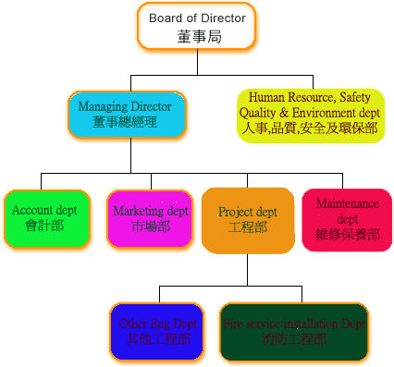

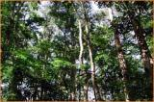 | Environment Protection  As a corporate citzen, we spares no effects to ensure environment and construction impacts arising from any construction activities are kept to the absolute minimum.  To ensure that our activities will be environmentally friendly, our company undertook a comprehensive environmental Impact Assessment on all projects. The findings and recommendations of the Environmental Impact Assessment are incorporated into our actions.  Sub-contractors and foreman are required to submit an Environmental Management Plan to the satisfaction of our comapny before works cancommence. The plan proposes effective mitigation measures to ensure full compliance with relevant environmental requirements.  While actual construction activities are in progress, our comapny own engineering supervisor monitors and audits contractors' plus foremen's performance to ensure contractual obligations are met. | 
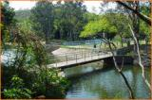 |  | 
 |  | 
 |  | 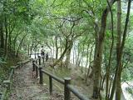
 |  | 

Occupational Safety and Health
  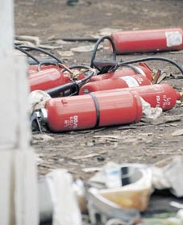
  扭開放氣 滅火筒炸傷工人
  9月 6日 星期六 03:45 更新
  【明報專訊】元朗山下村一個廢鐵回收場昨晨發生罕見滅火筒爆炸傷人意外，一名工人用士巴拿扭開滅火筒的樽頭，擬釋放樽內的壓縮二氧化碳，疑氣體因壓力轉變突猛烈湧出，引起爆炸，工人被炸至飛彈9呎外，血流披面受傷倒地，幸傷勢無礙。
  傷者陳創江，50歲，據稱從事廢鐵回收工作數十年，昨日送院時他耳、鼻及口部均受傷，血流披面，幸仍然清醒，在屯門醫院接受搶救及X光檢驗後，證實只是皮外傷，敷治後已出院。
  現場為元朗山下村近公立華封小學一個廢鐵回收場，場內放置大批舊冷氣及舊雪櫃等電器。近日，回收場收到一批共60個已過期失效的滅火筒，每個容量約9升，堆放在空地上。昨晨11時44分，陳從滅火筒堆中，抽起其中約10個放在地上，逐一用士巴拿扭開樽頭，打算待筒內的壓縮二氧化碳釋放後當作廢鐵賣。33歲何姓東主剛回到廢鐵場，距離陳約90呎，突聽到一聲爆炸巨響，見陳飛彈9呎倒地，即上前察看陳的傷勢及報警。幸二氧化碳不助燃，故沒引起火警。
  疑壓力改變
  消防接報到場調查，發現4個滅火筒的樽頭失去，有曾經泄漏的痕，懷疑滅火筒內剩餘二氧化碳因壓力轉變，突然湧出引起爆炸。消防事後在場開喉戒備及檢查其他滅火筒有否漏氣，待4個滅火筒內的氣體完全泄出後收隊。消防事後通知防火組到場跟進。

WKS Fire Engineering Co. takes the staff safety, besides establishes various types use the machine, this company is equipped with conforms with the security standard the work table, and the general work must the security tool, safeguards staff's safety. In addition, this company can for govern the staff to purchase the labor insurance and the necessary tool, and strictly requests each staff to have to use, otherwise, as soon as passes through the discovery, can receive the company to warn and the punishment.
Services Area
Supply、maintain、construct every types of building with different types of fixed fire services equipment，provide reliable and perfect services to design、consult、maintain、inspect、test and repair every types of fire services items at same times；
Sales portable equipment conforming to requirements of Hong Kong Fire Service departmnt including portable & fixed fire extinguishers、fire blanket、spray fire protection paints etc…
Every fire protection Engineering
Assisting in obtaining ventilation system certification
According to fire services department issuing instructions or warning from clients，carry out system improvement or maintenance、submitting documents plus drawings、follow up until warning cancel.
provide fire services design conforming to any terms or requirement from fire services lisence for dangerous good store, restaurnts and places of public entertainment.
Act as media among from structural engineer, architect, electrical engineer and so on to me, client obtain professional advice directly, avoiding waste a lot of time and money.

Examples
Ventilation sys
Fire Rated door
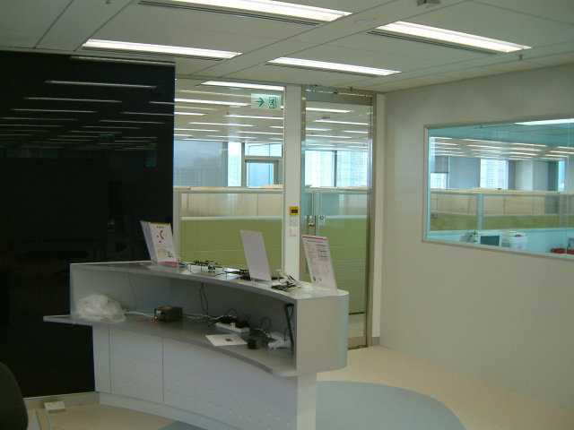
Emergency Lighting
Fire Rated Glass
Fire Resistant Paints
Break-glass unit

Product
Class 1 Fire Services Category Product
  Automatic Fire Alert system
  Fire control centre
  Fire alarm systems
  Dust detection systems
  Fire detection systems
  Gas detection systems
  Audio/Visual Advisory Systems
  Class 3 Fire Services Category Product
  Carbon Dioxide Type Fire Extinguisher
  Water Type Fire Extinguisher
  Dry Power Type Fire Extinguisher
  Foam Type Fire Extinguisher
  Fixed Automatically Operated Approved Appliances
  Clean agent Type Fire Extinguisher
  Foam (Chemical) Type Fire Extinguisher
  Fire Blanket
  Sand Bucket
Fire Protection Category Product
Fire Rated Glass Door
Fire Rated Timber Door
Fire Rated Glass
Other Fire Protection Product

  Class 2 Fire Services Category Product
  Fire Services Hydrant systems
  Fire Services Hose Reel systems
  Emergency lighting
  Water Spray Systems
  Supply Tank
  Fire Services Sprinkler Systems
  Automatic actuating devices
  Exit signs
  Automatic Fixed Installations Other Than Water
  Fixed Foam Systems
  Deluge Sprinkler Systems
  Drencher Systems
  Pressurization of Staircases
  Emergency Generator
  Fixed Fire Pump/Intermediate Booster Pump
  Ventilation Category Product
  Ventilation/air conditioning control systems
  Smoke extraction systems
  Gas extraction systems
  Other Products
  Directional Sign
  Fire Services Barrier
  Warning Sign
Job Reference
New installation, Addition & Alteration
Project | Completed Date | Address | Details: | Remark
Shalinar Restaurant | 29-6-2005 | Tsim Sha Tsui | Install Emergency lightings 、Exits Signs、Fire Alarm Systems、Fire Protection Paints、Kitchen Fire Damper
Hong Lee Court | On Progress | Kwun Tong | New installation of Fire Services Hose Reel | Yearly check: 31-5-2005
約翰教室 | On Progress | Tsuen Wan | Install Emergency lightings、Exits Signs、Fire Alarm Systems、Fire Protection Paints
曼谷泰菜 | On Progress | Aberdeen Second Shop | Install Emergency lightings、Exits Signs、Smoke Detector、Panel、Fire Alarm Systems、Submit FS314A、Fire Protection Paints、Flash light、Change Sprinkler system
瑞森工業大廈 | On Progress | Kwai Chung | Replace the wheel and nozzle of Fire Services Hose Reel 、break -glass unit、Fire Alarm Systems、Maintain the circuit of intermadiate boostup pump
Dosmetric Building | On Progress | D.D.I Lot 8.6.8 Lamma Island | New installation of Fire Services Hose Reel 、Street hydrant、Smoke Detector、break -glass unit、Fire Alarm Systems & Fire Services Pump、Fire Services Inlets、Fire extinguisher and so on
約翰教室 | 3-6-20005 | Tai Po | Install Emergency lightings、Exits Signs、Fire Alarm Systems、Fire Protection Paints、Change Sprinkler system、Submit FS314A
約翰教室 | 2-6-20005 | Fo Tan | Install Emergency lightings、Exits Signs、Fire Alarm Systems、Fire Protection Paints、Change Sprinkler system、Submit FS314A
約翰教室 | 2-6-20005 | North Point | Install Emergency lightings、Exits Signs、Fire Alarm Systems、Fire Protection Paints、Change Sprinkler system、Submit FS314A 、Smoke Detector、Panel
Mong Yip Engineering, Co. | 17-5-2005 | Kwai Chung Well Fung Ind. Bldg | Install Emergency lightings、Exits Signs、Change Sprinkler system、Submit FS314A
Upstairs Cafe | 4-5-2005 | Mong Kok | Install Emergency lightings、Exits Signs、Fire Alarm Systems、Fire Protection Paints、Panel、Flash light
南新雅賓館 | 3-5-2005 | Jordan | Install Emergency lightings、Exits Signs、Manual call point、Fire Protection Paints、Smoke Detector、Panel、Fire Alarm Systems、Flash light
曼谷泰菜 | 3-5-2005 | Aberdeen | Install Emergency lightings、Exits Signs、Manual call point、Smoke Detector、Panel、Fire Alarm Systems、Submit FS314A

Maintenance & Repair
Project | Date | Address | Detail | Remark
Casa Nostra O/B Born free LTD | 24-6-2005 | Central | Exit Signs
BB3 Bar & Cafe | 14-6-2005 | Tsim Sha Tsui | Fire alarm 、Flash light、Sprinkler
Hong Lee Court | negotiation | Kwun Tong | Fire alarm、Digital Manual call point、Fire services Hose Reel、Gate Valve、Nozzle | Year Check: 31-5-2005
瑞森工業大廈 | 27-5-2005 | Kwai Chung | Fire services Hydrant
慕情日本料理 | 24-5-2005 | Happy Valley | Exit Signs 、Emergency Lightings
貴盛工業大廈一期 | 17-5-2005 | Kwai Chung | Fire services Hydrant Replacement 、Fire services Hose Reel、Main Control、Fire alarm 、Sprinkler
真理浸信會富泰幼稚園 | 13-5-2005 | Tuen Mun | Fire services Digital Control panal (main & Sub)
僑江大廈 | 4-5-2005 | Yau Ma Tei | Fire services Inlet
Sun Lee Building | 2005 | Jordan | Yearly check and inspect Fire services Hose Reel system & Fire Hydrant、Maintain Sprinkler Pump 、Fire extinguisher and so on
旺德大廈 | 2005 | To Kwa Wan | Pump room 、Fire services Hose Reel system、Fire Servics Inlet
合一馬鞍山堂 | 2005 | Ma On Shan | Replace Sprinkler hose
大埔熙泰樓(住宅) | 2005 | Tai Po | Replace Fire Extinguisher

Interior Engineering
Project | Address | Completed Date | Detail | Remark
晴明眼鏡社有限公司 | Causeway Bay | On Progress | Painting、plastering、 Brick wall、Fire rated door、Electrical installation、submit WR1.
約翰教室 | Tuen Mun | 2-6-2005 | Painting、plastering、 Brick wall、Fire rated door、Electrical installation、submit WR1.
約翰教室 | Ap Lei Chau | 21-5-2005 | Painting、plastering、 Brick wall 、Fire rated door、Electrical installation, plus Fire Engineering & Sprinkler work、submit WR1及FS314A
The project is many, has not been able to record, welcome to deign to inquire.

Bangkok Thai Food(Aberdeen)
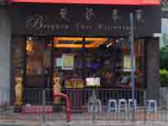 |  | 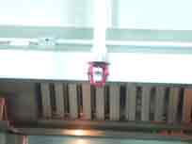
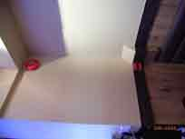 |  | 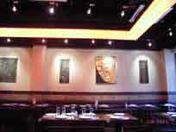

Hong Lee Court(Kwun Tong)
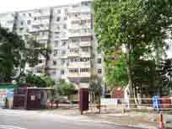 |  | 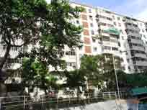 |  | 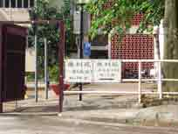
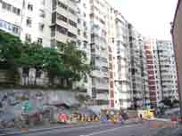 |  | 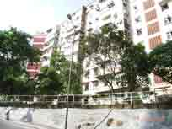 |  | 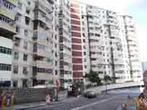
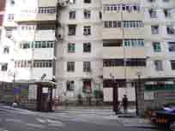 |  | 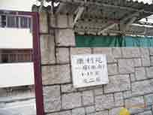 |  | 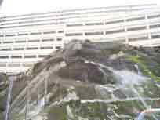

Shun Lee Building (Jordan)
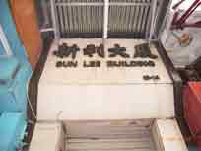 |  | 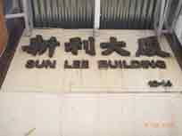 |  | 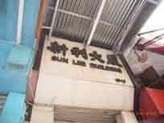
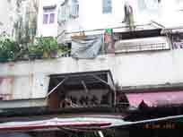 |  | 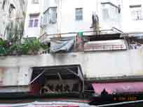 |  | 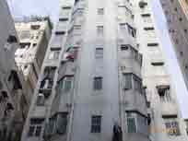
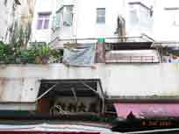 |  | 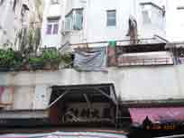 |  | 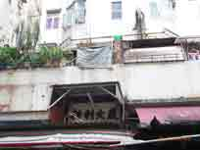
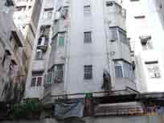 |  | 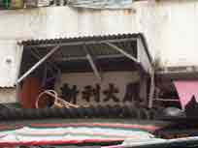 |  | 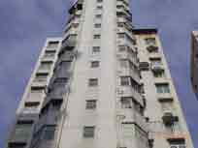

Company Name: | WKS Fire Engineering Co.
Contact Person : | Mr. W.Y. Cheng (Ricky)
Tel: | (852)2625 5554
Fax: | (852)2625 0035
E-mail: | wks_fire_eng@hkbn.com
Main Site : | http://www.wks.hk/
Mirror Site: | http://hkwks.sinacampus.com/
Backup Site: | http://hk.geocities.com/wksfec
Address: | Rm 4, Block A1, 15/F., Kin Hing Industrial Bldg, 17-23 Shek Kin Street, Kwai Chung
